**Ideation Phase**

**Define the Problem Statements**

|  |  |
| --- | --- |
| Date | 06 NOVEMBER 2023 |
| Team ID | NM2023TMID08291 |
| Project Name | Project – Estimation of business project |
| Maximum Marks | 2 Marks |

**Customer Problem Statement Template:**

Develop a robust expense estimation system to accurately predict and manage business expenses, ensuring optimal financial planning, cost control, and resource allocation. The system should encompass a wide range of expense categories, provide real-time tracking, and offer data-driven insights to support informed decision-making and sustainable financial growth.

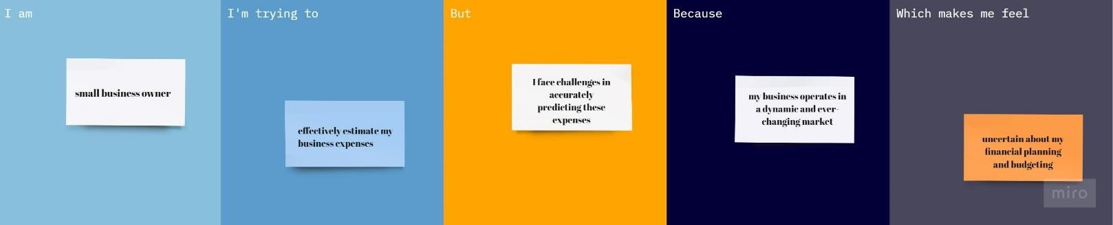

|  |  |  |  |  |  |
| --- | --- | --- | --- | --- | --- |
| **Problem**  **Statement (PS)** | **I am**  **(Customer)** | **I’m trying to** | **But** | **Because** | **Which makes me feel** |
| PS-1 | Small business owner | Effectively estimates my business expenses | I facing challenges  in  accurately  predicting these expenses | My business expenses in a dynamic and  ever changing market | Uncertain about my financial planning and budgeting |
| PS-2 | small business owner | forecast my annual  expenses accurately | I find it  challenging to do so | there are  various  unpredictable factors and  fluctuations in the market. | anxious about the financial stability of my business |